**Spring 2015**

**Advanced Software Engineering**

**Project Increment-IV (PG-9)**

**Project Title: Virtual Learning**

**Professor: Dr. Yugyung Lee**

**TA: Mayanka Chandra Shekar**

**Submitted By:**

Tejaswini Nalamotu (Class Id: 35)

Teja Mosali (Class Id: 34)

Manisha Kattukuri (Class Id: 27)

Bala Sai Teja Gaddam (Class Id: 15)

1. **Objective:**

Examinations plays a decisive role in the field of education to test the knowledge of an individual in a particular field. These examinations are of two types mainly paper based and online based. Earlier it is usually paper based but it has some disadvantages such as lengthy process, limited flexibility, high cost and it is also non Eco-friendly. These disadvantages can be overcome by replacing paper based examinations with online examinations. Most of the organizations have already changed their examination procedure from traditional paper based to modern online based. We have developed a web application called **“Virtual Learning”** which is an online based examination system.

1. **Imported Existing Services/APIs and REST Services:**

In our application virtual learning we have used Visual Studio as an Integrated Development environment. We are using APIs (Application Programming Interfaces) in order to integrate different functionalities into this web application. We have used Cascaded Style Sheets for styling of the web pages of this application. We have used Bootstrap for the look and feel of the Master page. Remaining all pages will inherit the look from the master page.

1. **Bootstrap:**

In our ASP.Net application we have used Bootstrap for the responsive HTML5 form and this Bootstrap makes these forms very fast and also light weight. We have included downloaded Bootstrap and JQuery into our web application. This helped us to give different types of animations and styles to our application. By using Bootstrap classes such “navbar”, “btn btn-common btn-lg” and “animated fade” we have designed Master page along with home page and contact us page. By using Bootstrap we have totally changed the look and feel of the web pages of our application.

1. **Google Search API:**

The Google Search Application Program Interface provides a search bar. By using this search bar user can search any topic he/she want. Whether it related to GRE or CAT or any other topics, user can easily search by using this Google Search API.

1. **Yahoo Search API:**

The Yahoo search Application Program Interface provide a search bar by using which we can search about the people of user’s interest. If any user want to find the information about the tutors who are providing classes for GRE and CAT, they can use Yahoo search API to find the information.

1. **Barcode:**

The barcode feature provides every user with a unique barcode. After scanning this barcode we will get the student id of that user. Code39 type barcode is user for our application. By using letters, numbers or both we can generate code39 type of barcode. Special characters such as $ @ _ , . / can also be used in this barcode. This barcode has delimiters at the both ends which are nothing but stars. The starting point and ending point of any word can be determined by these stars. Upon scanning of the barcode we will get the word, but we can retrieve the stars in it.

When we scan the barcode from a barcode scanner the output will be as follows,

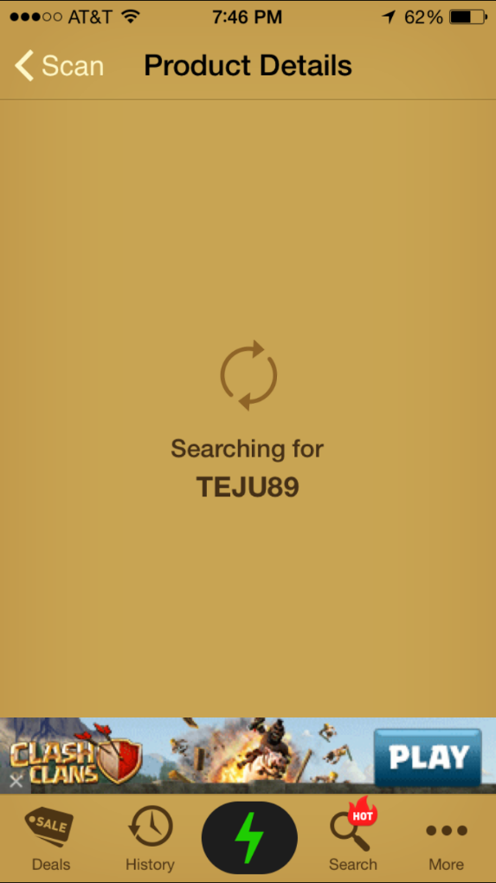 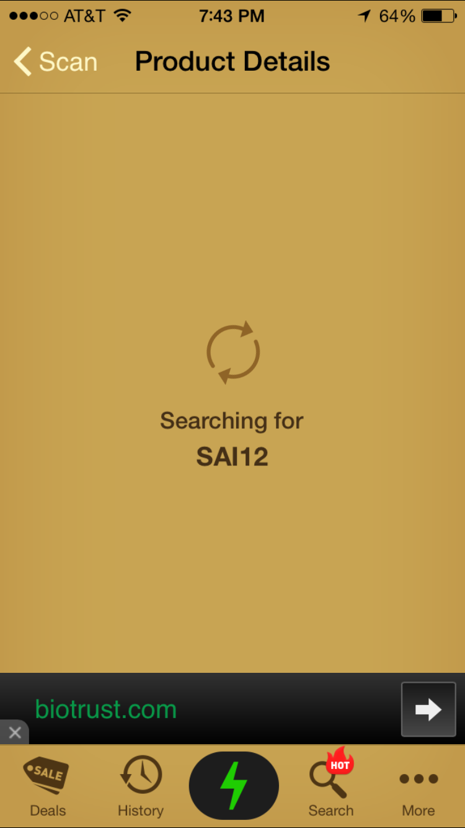

1. **Google MAPS API:**

As we are providing the addresses of the tutors who are giving classes in GRE and CAT, so we using Google MAP Application Programming Interface to provide the location of the tutors and also the directions to reach those tutors. From Google Developer Console, we have extracted the key by using which we can use Google MAP API.

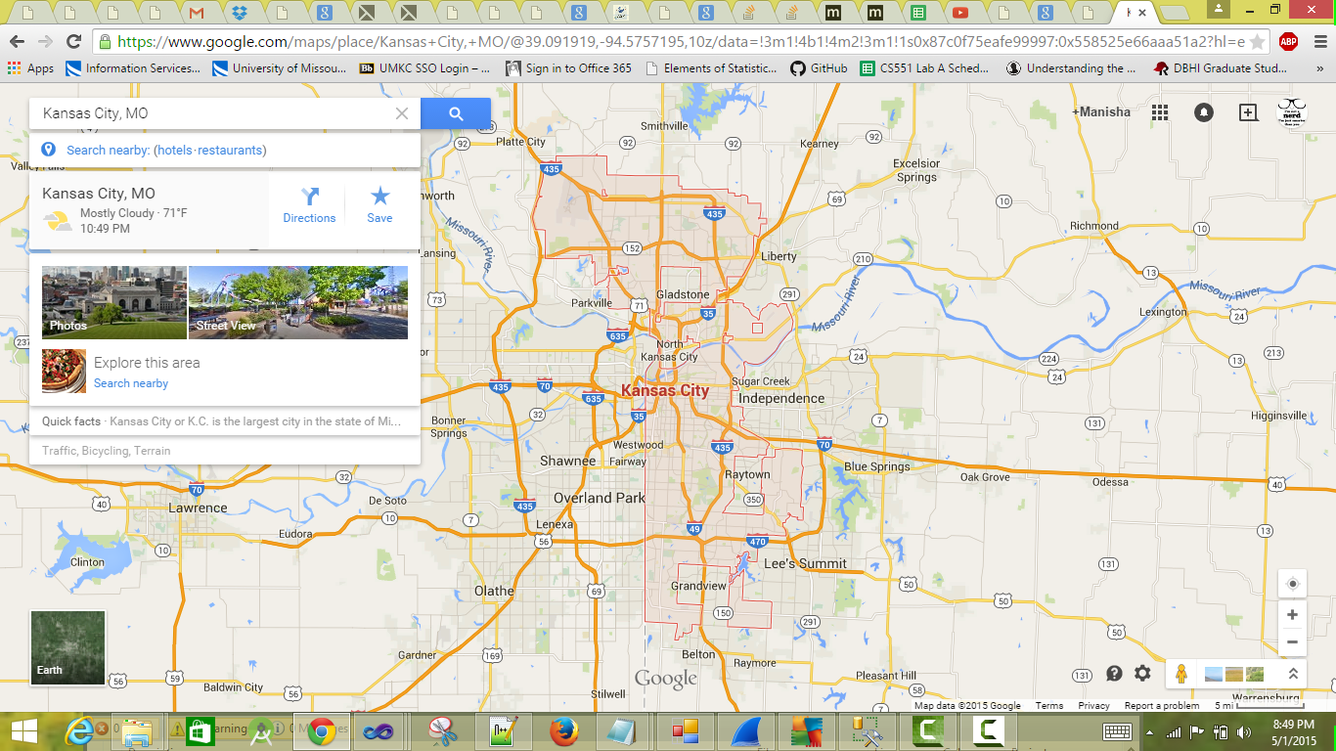

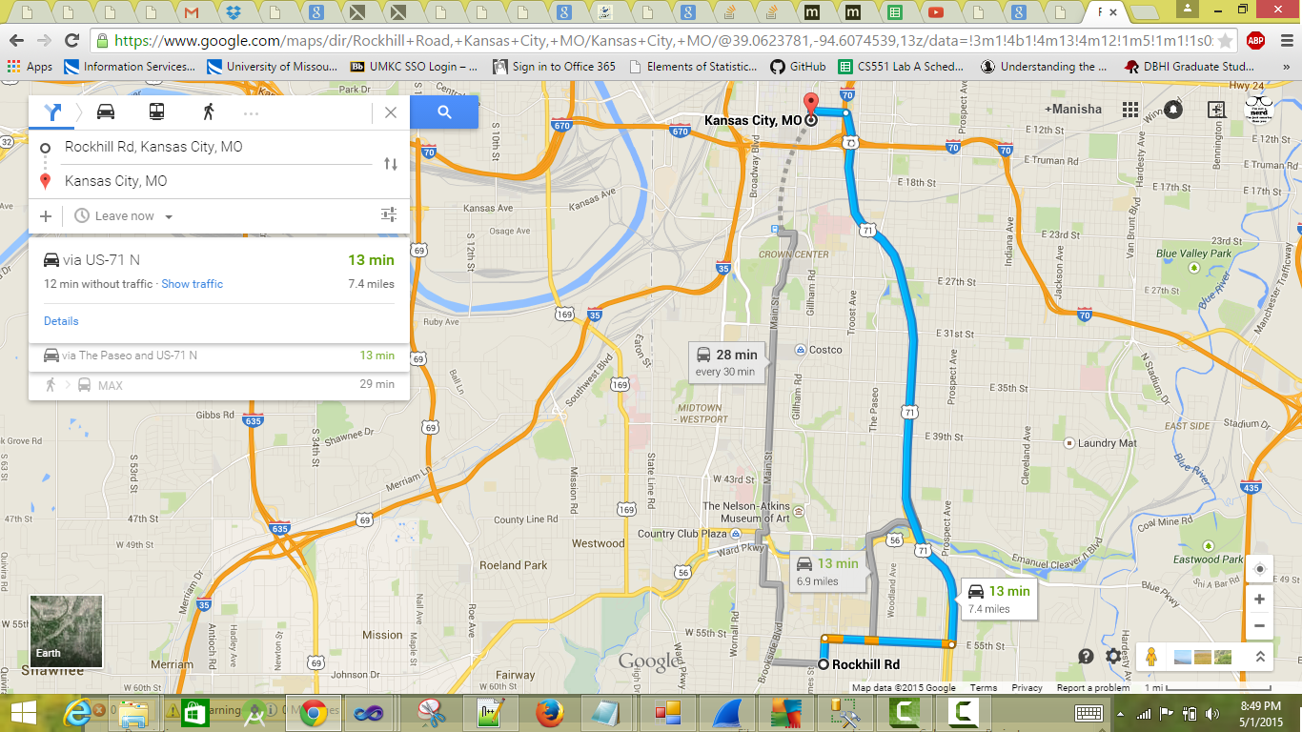

1. **REST service to get the questions:**

[{"answer":"3","options":["Charless Chabb","Charless Rich","Charless Babbage","Charless Cun"],"question":"Who is father of Computer ?"},{"answer":"2","options":["Graduate Repute Exam","Graduate Record Exam","Graduate Reconcile Exam","Graduate Revival Exam"],"question":"What is GRE?"}]

This REST service is used to retrieve the attributes like question, correct answer and different options for the questions. We provide the level of the exam and the type whether it is GRE or CAT. We have invoked this REST service in our web form and the final test form and this provides the level and the type of the exam.

1. **Weather REST Service:**

This rest service is used to for the students to check the weather whenever the student want to meet the tutors .As the weather in the US is unpredictable the students need to check the weather in forehand in order to predict the climatic conditions. In this rest service we need to give the state zip code, then the weather for the corresponding state will be displayed. As the weather will be changed dynamically the temperature that will be changed will also be displayed dynamically.

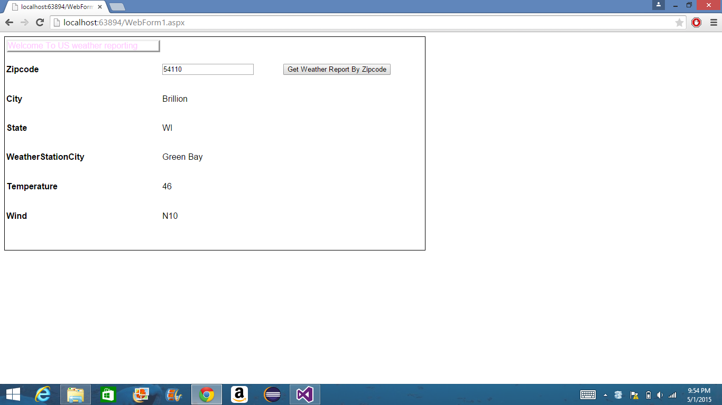

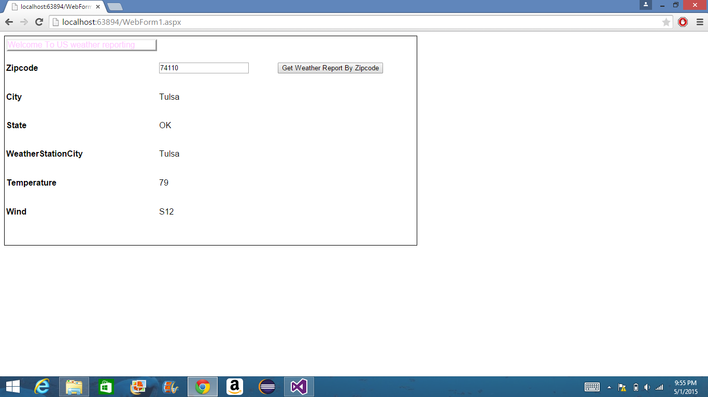

1. **Calculator:**

It is a simple calculator which is used to calculate the additions, multiplications and divisions. When the students are taking the online test, there are some bits which needs calculator to find the solution within the time specified. So, we provided this simple calculator to the students to speed up their calculations.

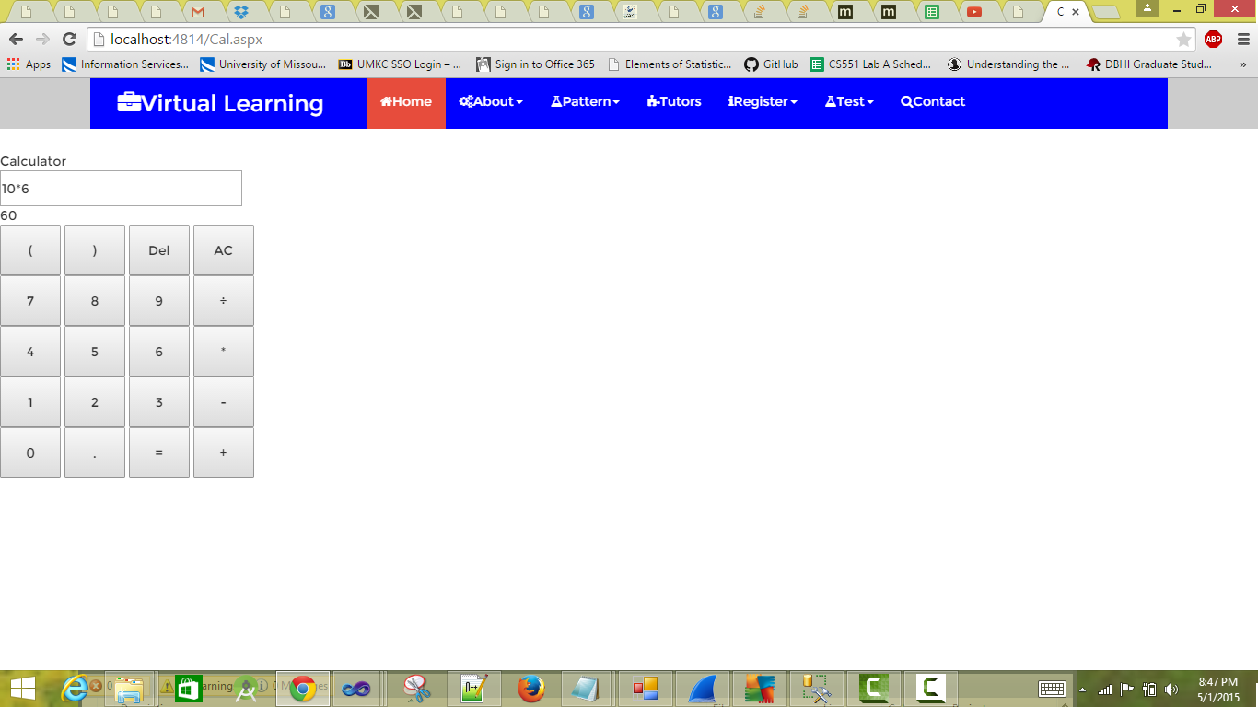

1. **Design of Services:**
2. **User Stories:**

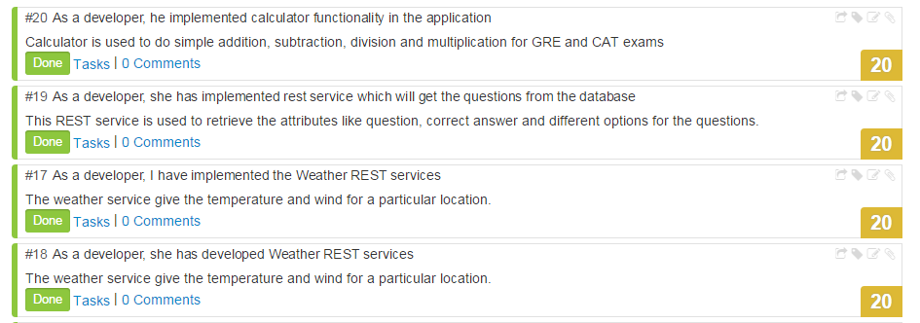

1. **Service Description:**

We have used Visual Studio ASP.Net to create the applications. These ASP.Net web services can be easily understood by any individual. We can develop applications and services by using ASP.Net. To generate web form applications we can use templates of ASP.Net. This provide some of the functionalities given below,

* Navigation with menu control
* CSS
* Home or Master page
* ASP.Net security
* Ajax scripting along with JQuery

There are some default features for these templates such as,

* Global application class
* Master page
* Web config file
* Package config file
* Client script files and membership files are embedded in a folder along with CSS files

1. **Sequence Diagram:**

**Admin:**



**Student:**



1. **Class Diagram:**

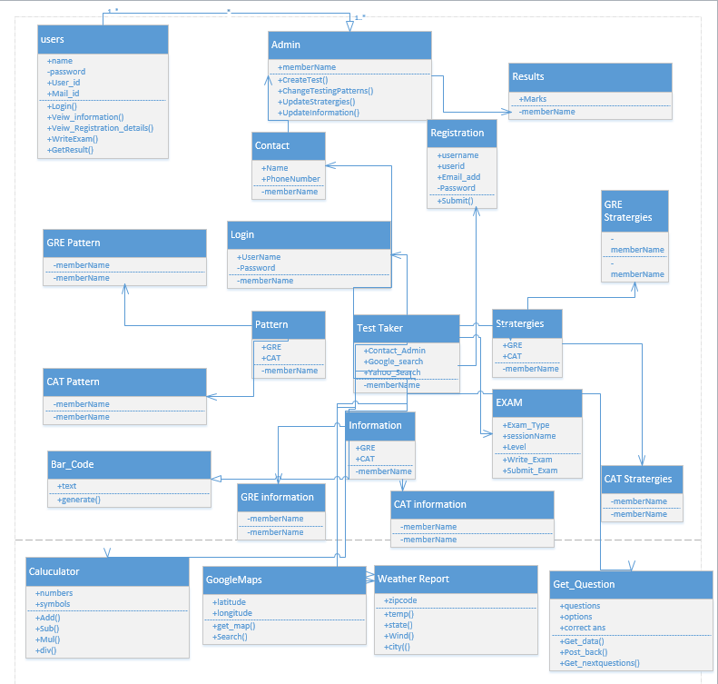

1. **Screenshots with Explanation:**
2. **Master Page:**

Master page is the most pivotal part of the entire application. By using Bootstrap classes such “navbar”, “btn btn-common btn-lg” and “animated fade” we have designed Master page. All other pages inherit this master page such as home page, patterns page, login page and registration pages. Master page has all the buttons for the remaining web pages of the application.

1. **Home Page:**

We have inherited the master page to give the same look and feel for the home page. It contains two buttons namely Login and Registration. Those two buttons will be redirected to the login page and user registration page.

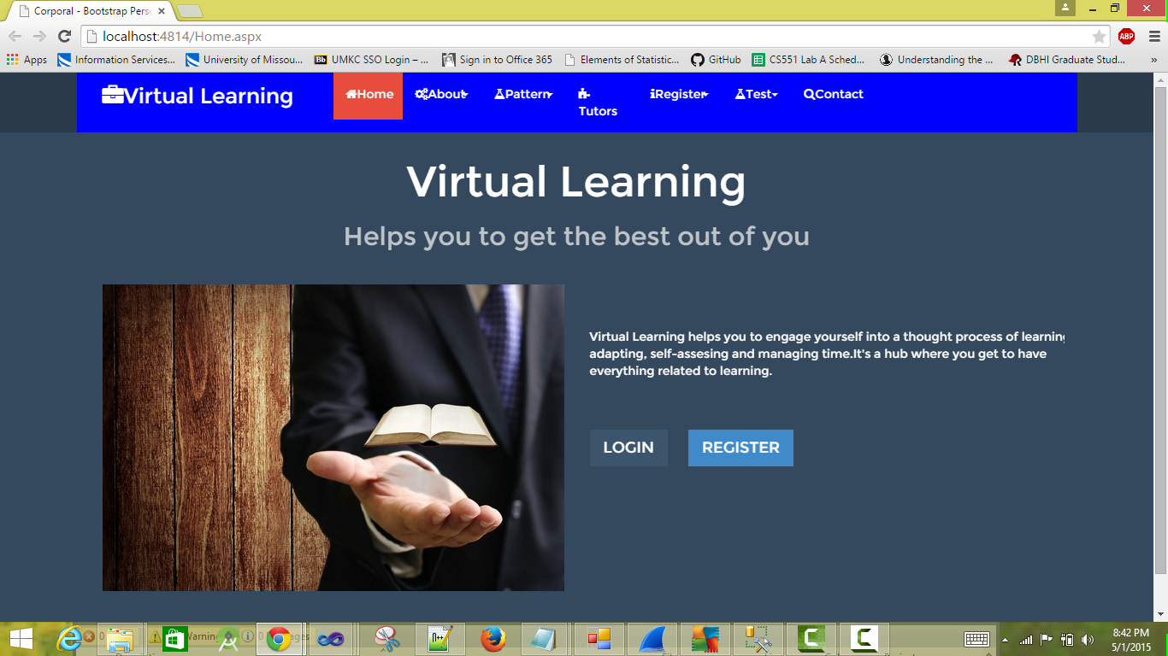

1. **User Registration Page:**

This page is for those users who are new to the virtual learning application. To get access to this virtual learning application, they can register to this applications by giving appropriate credentials in the fields provided. All these credentials will be stored in the database. An error message will be provided to the user if they give wrong credentials such as giving numbers or special characters at the place of name. Another error will be shown if any user does not give credentials for all mandatory fields. If error is displayed user needs to modify and give proper credentials for all required fields in order to complete the registration. After the completion of the registration users can use the functions of the application.

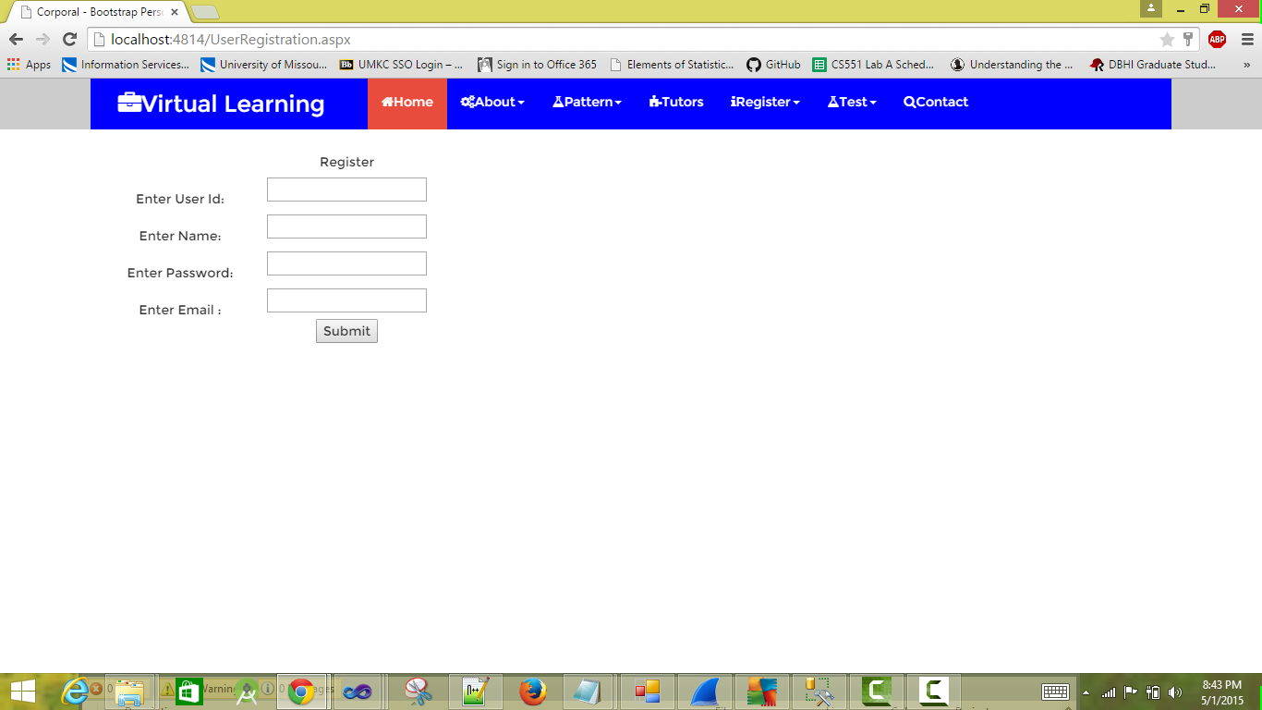

1. **User Login Page:**

After the completion of the registration, user can use the application by log in page provided in the home page by giving proper credentials. If the credentials given by the user are not correct according to the data in the database, an error message will be shown to the user and user cannot use the application. In order to get access without any interruptions user must give the credentials used at the time of registration. After giving correct details such as user name and password, user can user all the functionalities of the application without any interruption. User can access all the pages such as information, pattern, strategies, and tutors along with mock test page. Login page also contains Google search bar and Yahoo search bar using which user can search any topic of his interest.

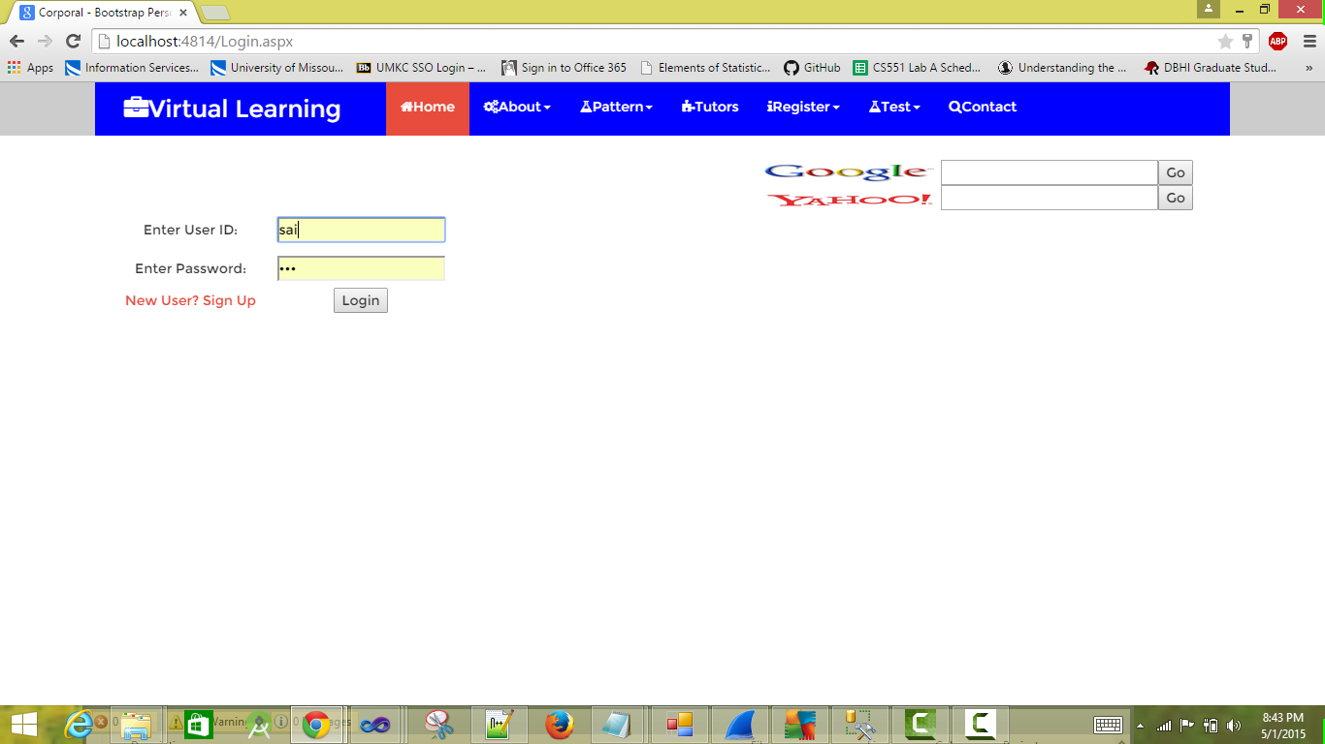

1. **Information Page:**

This page provides the complete information user needs to know about GRE and CAT before planning for the exam. This page includes the topics on which exam is going to be conducted. By using this information user can plan effectively for the exam.

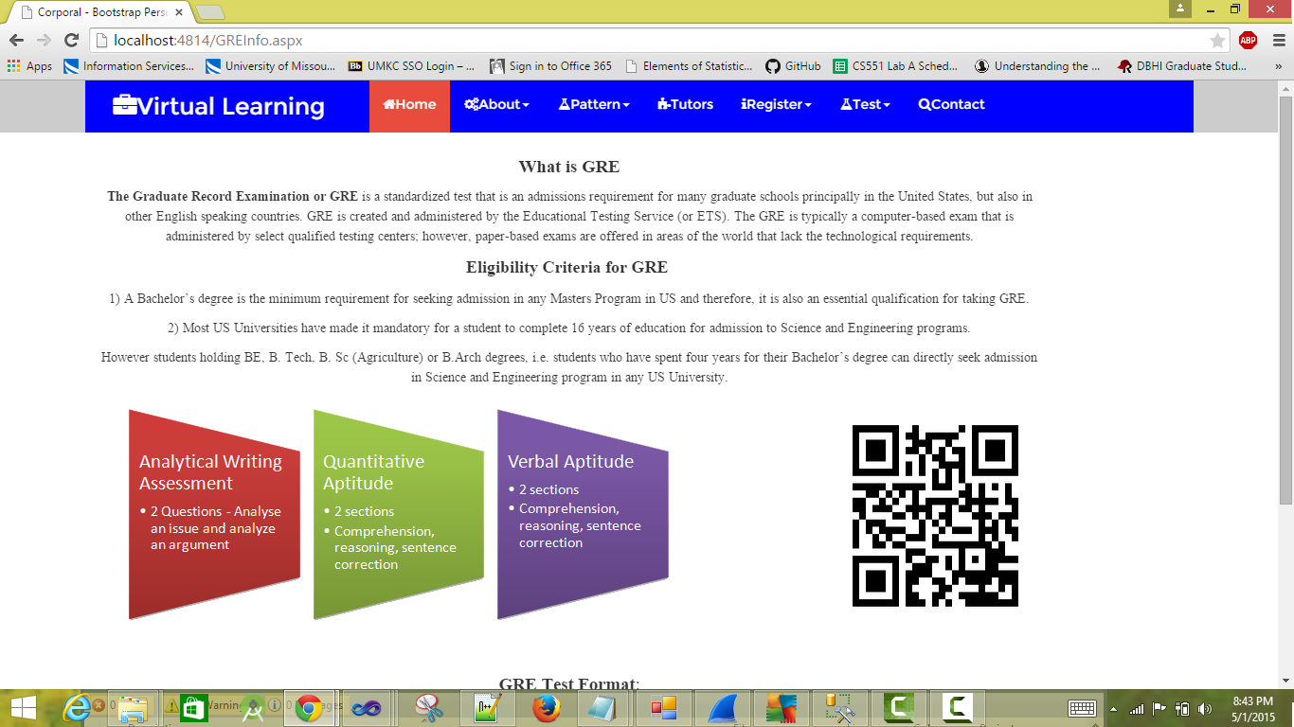

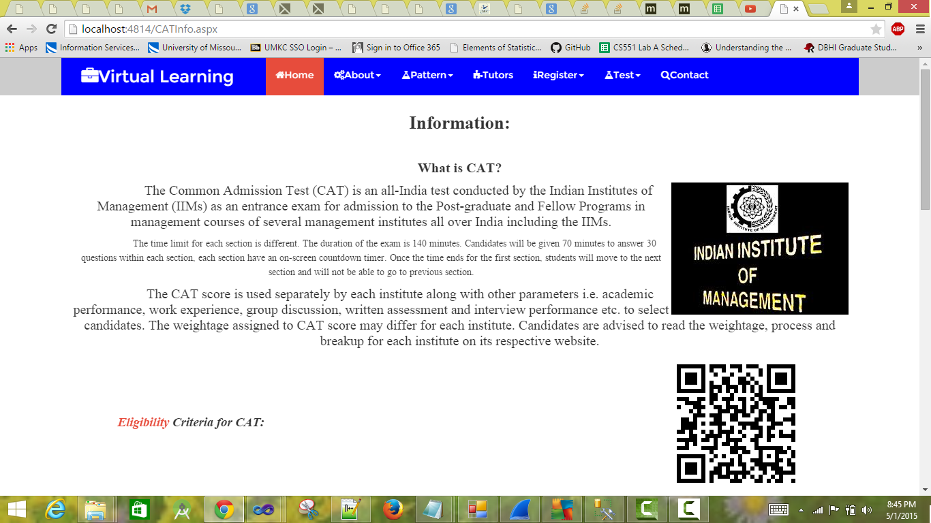

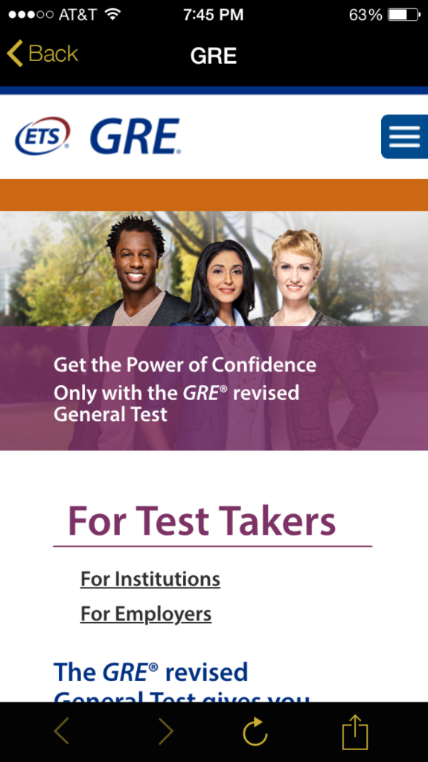 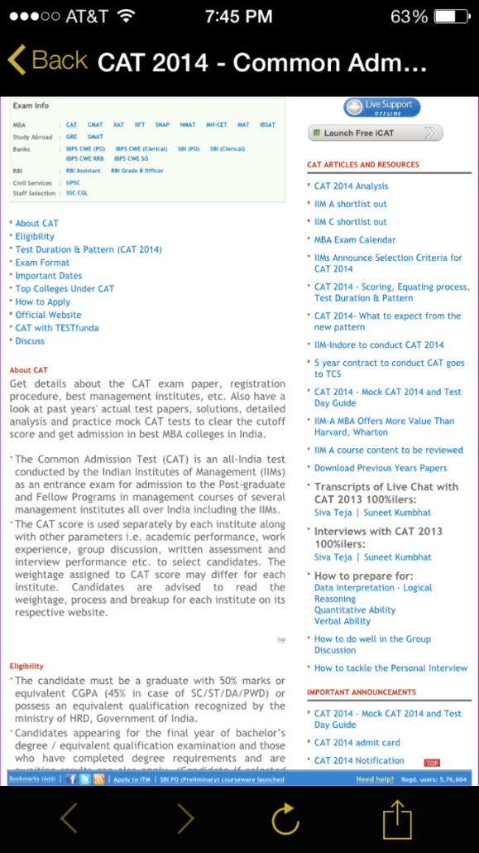

1. **Pattern Page:**

Before attending the exam everyone need to know the pattern of the exam without which succeeding the exam is very difficult. Exam pattern for both GRE and CAT has been given in the pattern page for the users to view. The information includes the sections given in the exam, marks allotted for each section and time provided to complete the exam.

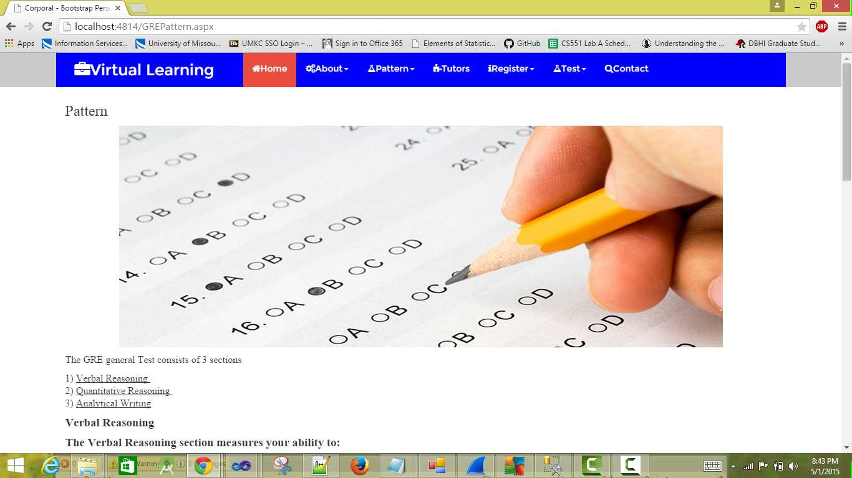

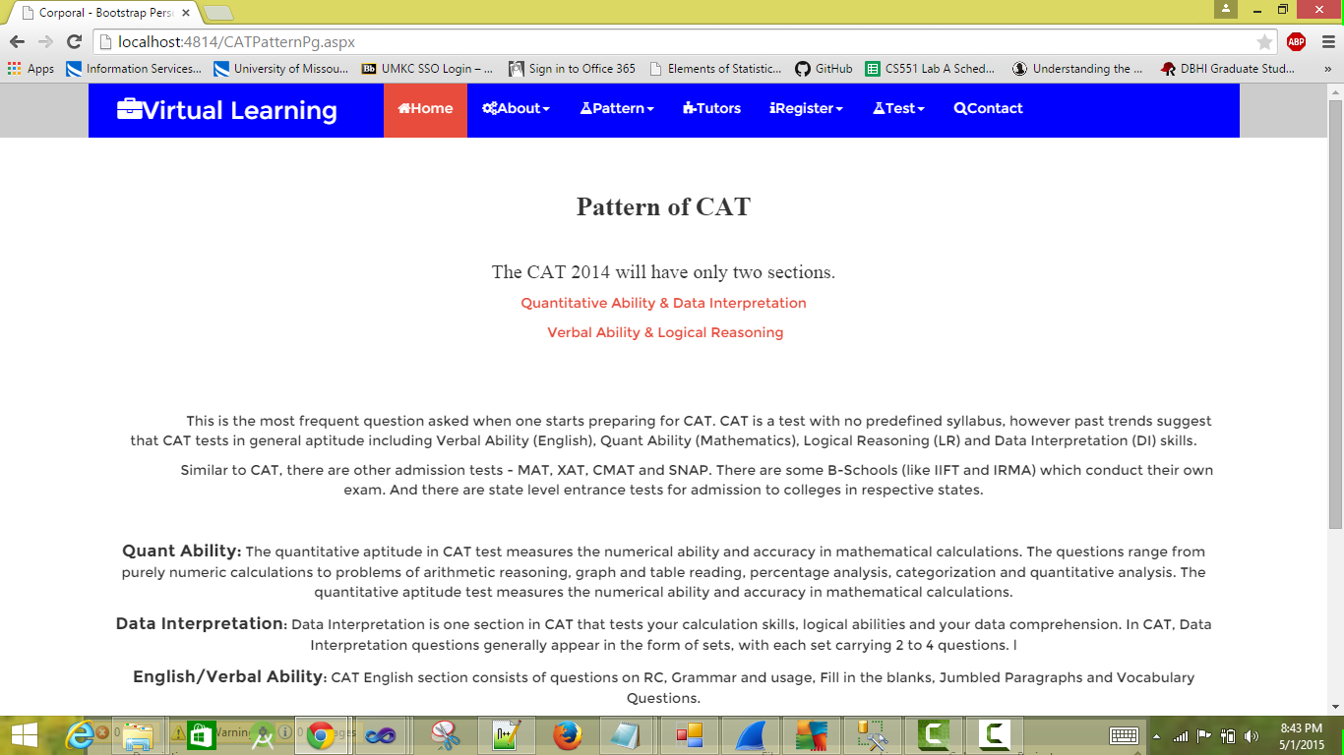

1. **Strategies Page:**

For the success of any examination strategies plays a crucial role. We have given strategies for CAT as well as GRE in the strategies page provided in the application. By using these strategies users can amplify their performance. Strategies are different for both GRE and CAT.

1. **Registration Details Page:**

Registration for the test is must before taking any type of exam. According to ETS (Educational Testing Service) we have provided the registration details for GRE and also we have given the details for CAT. These registration details includes location of test centers, dates for the test, time for the test and also examination fee for the tests.

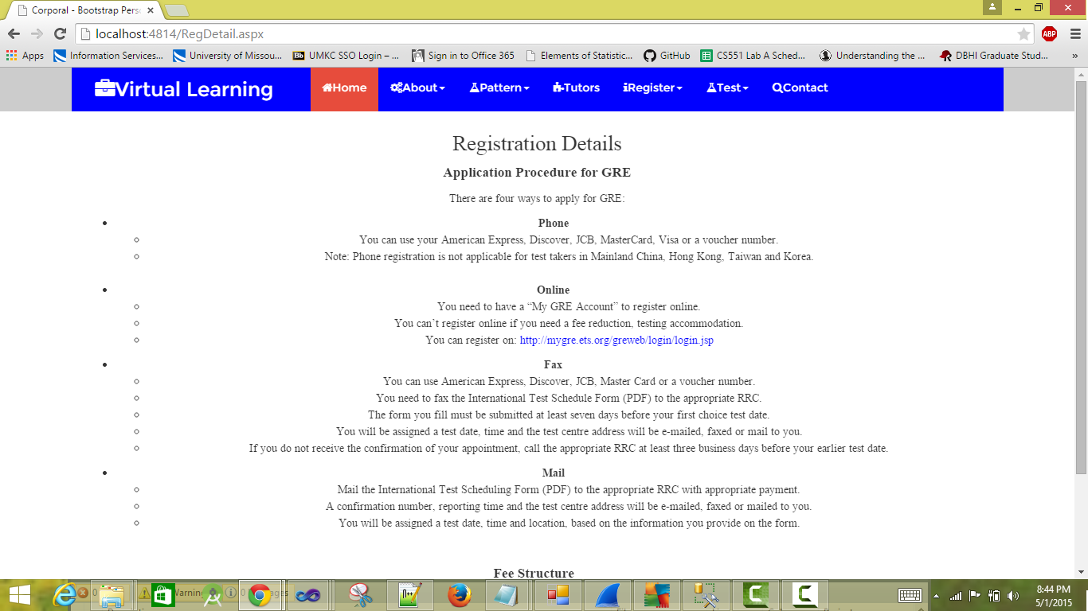



1. **Mock Test Page:**

Before taking the original exam, we can check our capabilities by taking the mock tests for any particular area. We can change our strategies and learning methods according to the results of the mock test to improve our performance in the main test. If the mock test result for a student is low, he/she can point out the mistakes he/she did in the exam and can improve their knowledge in that particular area. We have provided three mock tests in our application each with a time limit of 10 minutes.

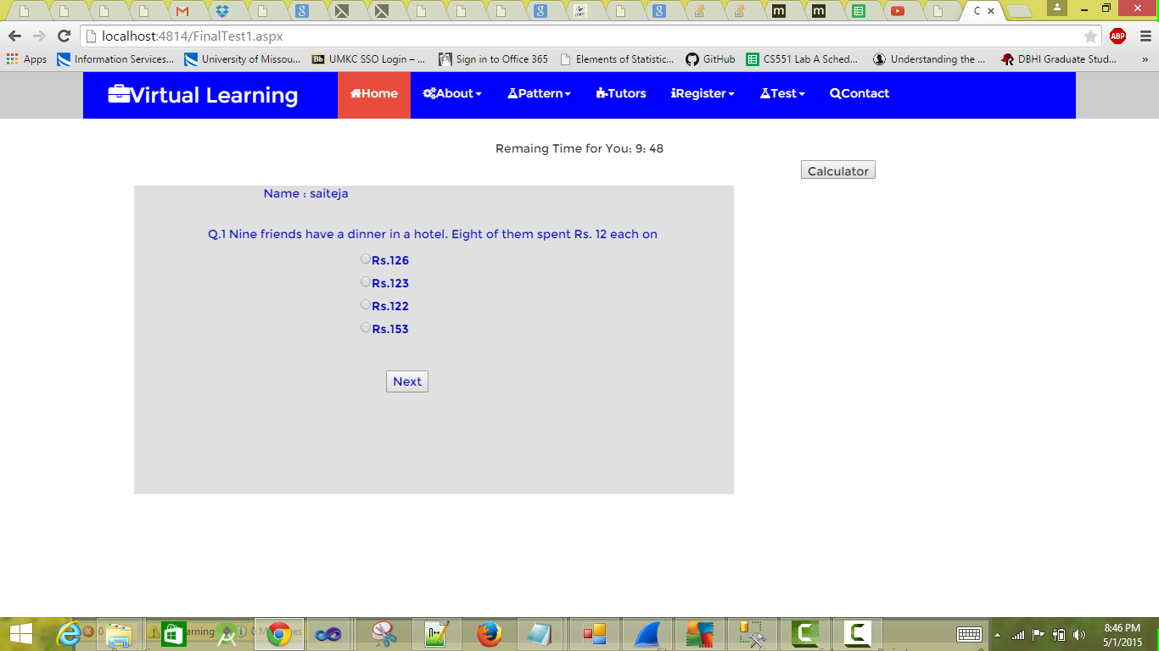

1. **Tutors Page:**

If any student wants any mentoring for any topics, he/she can contact the tutor who is providing tutoring for that particular topic. To help users with this, we are providing addresses of the tutors who are providing the tutoring services in the field of GRE and CAT. We have included Google MAPs Application Programming Interface in our application, so that user can find the location of tutor and the directions to reach him/her.

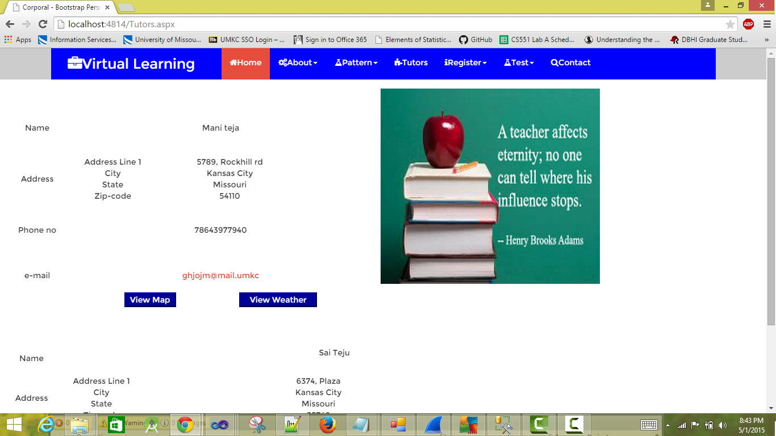

1. **Contact Us Page:**

If any user have any questions regarding the application, then he can contact the application providers by using the contact us page provided. After proving their name, email id and subject of their question, they can write their question in the message box provided in the contact us page and by clicking the send button they can send that message to the application providers.

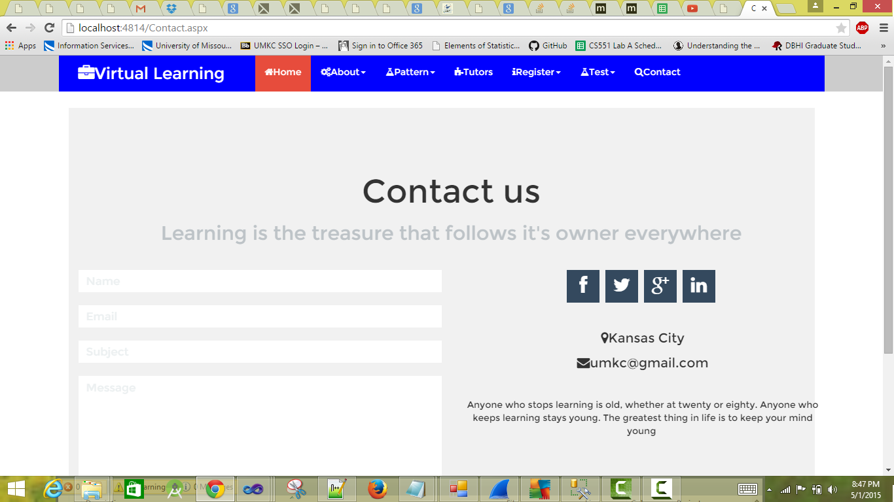

1. **Testing:**
2. **Google Chrome:**



Firstly we have Google chrome as the platform and calculated the time taken to run the project on it, the taken was 1.59 seconds (For displaying the master page).The average time taken to navigate from one web to the other web was 0.57 seconds. In order to have the good look and feel I have also placed the screen shot that we have used in Google chrome.

The following are the results among many of the results that are taken several times

To open Home page: 1.59

GRE Info form: 0.54

CAT Info form: 0.48

Pattern form of GRE: 0.47

Pattern form of CAT: 0.51

Strategies Form of GRE: 0.47

Strategies Form of CAT: 0.46

Registration form of GRE: 0.49

Registration form of CAT: 0.45

Mock Test page: 0.57

1. **Internet Explorer:**



We have computed the time taken in the internet explorer to run the project. The platform chosen to run the project was internet explorer, the time taken on an average in this platform was 1.36. The time taken to navigate from one web to another web was 0.58 seconds .

The following are one of results among many

To open Home page: 1.37

GRE Info Form: 0.58

CAT Info form: 0.60

GRE Pattern form: 0.54

Pattern form of CAT: 0.55

Strategies Form of GRE: 0.54

Strategies Form of CAT: 0.56

Registration form of GRE: 0.58

Registration form of CAT: 0.51

Mock Test page: 0.61

1. **Mozilla Firefox:**

The time taken to run our project in Mozilla Firefox was Calculated several times .The time taken to run our project on an average was 1.54 seconds. To navigate from one web to the other web the time taken on an average was 0.57 seconds.

1. **Safari:**

The time taken to run the project in order to run the project is 1.51 seconds. In safari the taken to run our project was calculated several times. In order to traverse from one web to another web the time taken on an average is 0.58 seconds.

By comparing all the above results and the time taken to navigate to display the home screen is very less for the internet explorer with respect to the other four Web Browsers for example Google chrome.

1. **Deployment:**
2. **Scrum Do:**

[**https://www.scrumdo.com/projects/project/virtual-learning2/iteration/127058**](https://www.scrumdo.com/projects/project/virtual-learning2/iteration/127058)

[**https://www.scrumdo.com/projects/project/virtual-learning2/iteration/127058/board**](https://www.scrumdo.com/projects/project/virtual-learning2/iteration/127058/board)

1. **Project URLs:**

[**http://localhost:59563/Home.aspx**](http://localhost:59563/Home.aspx)

[**http://localhost:** **59563/UserRegistration.aspx**](http://localhost:%2059563/UserRegistration.aspx)

[**http://localhost:** **59563/GREInfo.aspx**](http://localhost:%2059563/GREInfo.aspx)

[**http://localhost:** **59563/CATInfo.aspx**](http://localhost:%2059563/CATInfo.aspx)

[**http://localhost:** **59563/GRERegdetail.aspx**](http://localhost:%2059563/GRERegdetail.aspx)